ELEN 50 – W17 HW#4

(due March 10 before class)

1. What is the complex impedance, Z, of this circuit at  = 105 rad/sec?

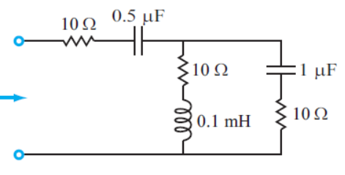

Z



1. Reduce this circuit to a single equivalent capacitor:





1. At what angular frequency,  is the current, i(t) in phase with the applied voltage vs(t)?





1. Find the voltage v(t) and current i(t) in this circuit. The switch closes at time t=0.



At time t=0, v(t) = Vs and i(t)= 0. After a long time (many time constants) the current will be limited by the 50 resistor only so i= 100V/50 = 2A and v = 0 because di/dt through the inductor is zero. The transient response of the circuit is given by:



So:

